Sahu Garments

Software Requirements Specification

INT 252

Anjeet Patel
12210752

Prepared for
Continuous Assessment 3
Autumn 2024

Revision History

Date | Description | Author | Comments
<date> | <Version 1> | <Your Name> | <First Revision>
25/10/24 | 1.0 | Anjeet Patel | Standard prototype

Table of Contents

Revision History i
1. Introduction 1
1.1 Purpose 1
1.2 Scope 1
1.3 Definitions, Acronyms, and Abbreviations 1
1.4 References 2
1.5 Overview 2
2. General Description 2
2.1 Product Perspective 2
2.2 Product Functions 2
2.3 User Characteristics 3
2.4 General Constraints 3
2.5 Assumptions and Dependencies 3
3. Specific Requirements 3
3.1 External Interface Requirements 3
3.1.1 User Interfaces 3
3.1.2 Hardware Interfaces 4
3.1.3 Software Interfaces 4
3.1.4 Communications Interfaces 4
3.2 Functional Requirements 4
3.2.1 <Functional Requirement or Feature #1> 4
3.2.2 <Functional Requirement or Feature #2> 4
3.5 Non-Functional Requirements 3
3.5.1 Performance 3
3.5.2 Reliability 3
3.5.3 Availability 3
3.5.4 Security 3
3.5.5 Maintainability 3
3.5.6 Portability 3
3.7 Design Constraints 3
3.9 Other Requirements 3
4. Analysis Models 5
4.1 Data Flow Diagrams (DFD) 4
5. Github link…………………………………………………………………………………………………….5
6. DEPLOYED LINK………………………………………………………………………………………………...6
7. CLIENT APPROVAL PROOF……………..…………………………………………………………………….7
8. CLIENT LOCATION PROOF……………………………………………………………………………………8
9. TRANSACTION ID PROOF……………………………………………………………………………………...9
A. Appendices
A.1 Appendix 1
A.2 Appendix 2

1. Introduction

1.1 Purpose

The purpose of this document is to establish a comprehensive Software Requirements Specification (SRS) for the Sneaker Hub e-commerce platform. This document is intended to guide the development team, stakeholders, and other relevant parties in understanding the goals, functionalities, and constraints of the Sneaker Hub project. This documentation will support future maintenance and ensure the platform meets both client and user expectations.

1.2 Scope
This subsection should:Sneaker Hub will serve as a one-stop platform for sneaker enthusiasts and collectors. It will allow users to browse, compare, and purchase a curated collection of sneakers from various brands, with features including user authentication, cart management, secure payments, and tracking. The scope of this project encompasses
Web application with responsive design for mobile and desktop users.
Backend infrastructure to support large data transactions and high-traffic spikes.
Integration with third-party services like payment processors and social media login.
Detailed analytics for client insights and user engagement.

1.3 Definitions, Acronyms, and Abbreviations

UI: User Interface - Elements users interact with directly.

API: Application Programming Interface - Allows communication between different software entities.

UX: User Experience - Overall experience of the end-user.

DBMS: Database Management System - Software for managing data.

GDPR: General Data Protection Regulation - Regulations for user data privacy.

1.4 References

MongoDB Documentation

Express.js Guide

React Documentation

Node.js Guide

Web Design and UX Principles for E-Commerce

1.5 Overview

This document includes a general description of Sneaker Hub, specific functional and non-functional requirements, analysis models, interface descriptions, and additional sections to assist in the development, deployment, and maintenance phases.

2. General Description

2.1 Product Perspective
Sneaker Hub will integrate with major sneaker brands and suppliers to provide a seamless shopping experience. The product will include an interactive catalog of sneakers with advanced search and filtering capabilities. The platform will stand out due to its user-centric design, high-quality imagery, and customization options, creating a unique space for sneaker enthusiasts.

2.2 Product Functions

Key functionalities include:

Search and Browse: Users can search and filter sneakers by brand, color, size, and price.

Cart Management: Add, remove, and update cart items.

Secure Checkout: Integration with payment gateways for safe transactions.

User Accounts: Allow users to register, log in, and view order history.

Notifications: Send email and SMS notifications for order confirmation and shipping updates.

Inventory Management: Admins can manage stock levels and product details.

2.3 User Characteristics
End Users: Typically aged 18-35, familiar with e-commerce.
Admins: Responsible for managing product listings, orders, and inventory.
Guest Users: Can browse products without creating an account but must sign up to purchase.

2.4 General Constraints

Device Compatibility: Responsive design for mobile, tablet, and desktop users.

Latency: Webpages should load in under 3 seconds.

Security: Must comply with industry security standards and data protection regulations (GDPR).

2.5 Assumptions and Dependencies
Reliable third-party API access for payment and social login.
Internet connectivity is required to access the platform.
External dependencies such as databases and servers will have redundancy measures to prevent downtime..

3. Specific Requirements

3.1 External Interface Requirements

3.1.1 User Interfaces
Homepage: Features trending sneakers, promotions, and search bar.
Product Page: Detailed views of each sneaker with images, specifications, and reviews.
Cart: Displays added items, quantities, and total price.
Checkout: Payment options and shipping address fields.
User Profile: Shows order history, saved items, and account settings.

3.1.2 Hardware Interfaces
The platform must be optimized for desktops, tablets, and smartphones across different resolutions and screen sizes.

3.1.3 Software Interfaces
Payment Gateway Integration: Connect with Stripe or PayPal for secure payments.
Authentication: Integration with Google and Facebook for login options.
Database: Uses MongoDB for data storage and retrieval.

3.1.4 Communications Interfaces
Email/SMS: Confirmation and notification for orders, promotions, and user support.

3.2 Functional Requirements
This section describes specific features of the software project. If desired, some requirements may be specified in the use-case format and listed in the Use Cases Section.

3.2.1 <Functional Requirement or Feature #1>

3.2.1 Browse Sneakers

Users can view sneakers with sorting and filtering options by brand, price, size, and color.

3.2.2 Product Search

A search bar enables users to find specific sneaker models or brands.

3.2.3 User Authentication

Users must be able to create an account, log in, and reset their passwords.

3.2.4 Cart Management

Users can add, update, or remove items from their cart and proceed to checkout.

3.2.5 Payment Processing

Integration with Stripe/PayPal for secure transactions.

3.2.6 Order Tracking

Users can view the status of their orders from the profile section.

3.2.7 Admin Inventory Management

Admins have access to an inventory management system to add/edit products, monitor stock, and track orders.

3.5 Non-Functional Requirements
Non-functional requirements may exist for the following attributes. Often these requirements must be achieved at a system-wide level rather than at a unit level. State the requirements in the following sections in measurable terms (e.g., 95% of transaction shall be processed in less than a second, system downtime may not exceed 1 minute per day, > 30 day MTBF value, etc).

3.5.1 Performance
The site must support 10,000 concurrent users, with a target response time under 2 seconds per action.

3.5.2 Reliability
The platform must have a 99.9% uptime, supported by server redundancy and cloud infrastructure.

3.5.3 Availability
24/7 availability with minimal downtime; scheduled maintenance will be announced in advance.

3.5.4 Security
- Data Encryption: SSL/TLS encryption for data in transit.
- User Privacy: Compliance with GDPR and CCPA.

3.5.5 Maintainability
Modular codebase for easy updates; maintenance scheduled quarterly.

3.5.6 Portability
The website must function across major web browsers and operating systems.

3.7 DESIGN CONSTRAINTS
The UI design will emphasize usability and accessibility, with clear navigation, prominent calls-to-action, and optimized images for loading speed.

3.9 OTHER REQUIREMENTS
The platform must meet WCAG 2.1 AA accessibility guidelines to ensure usability for all users, including those with disabilities.

4. Analysis Models
List all analysis models used in developing specific requirements previously given in this SRS. Each model should include an introduction and a narrative description. Furthermore, each model should be traceable the SRS’s requirements.

4.1 Data Flow Diagrams (DFD)
The following DFDs illustrate data flows:
. Analysis Models
4.1 Data Flow Diagrams (DFD)

i) 0-level DFD

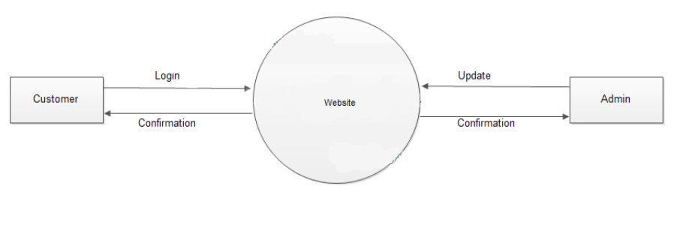
ii)1-level DFD

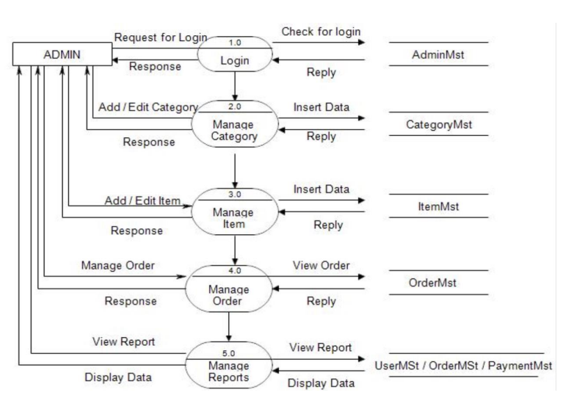

Screenshots of the website:-

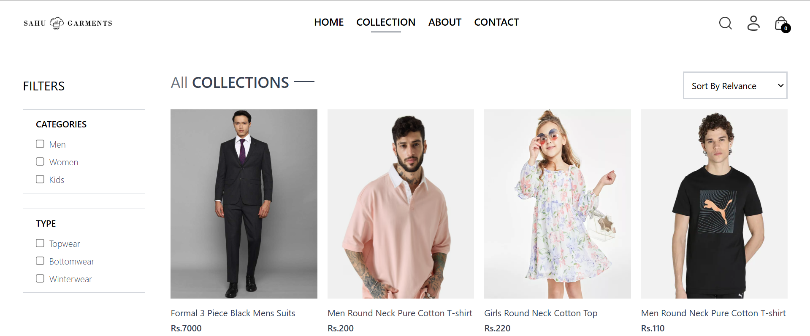

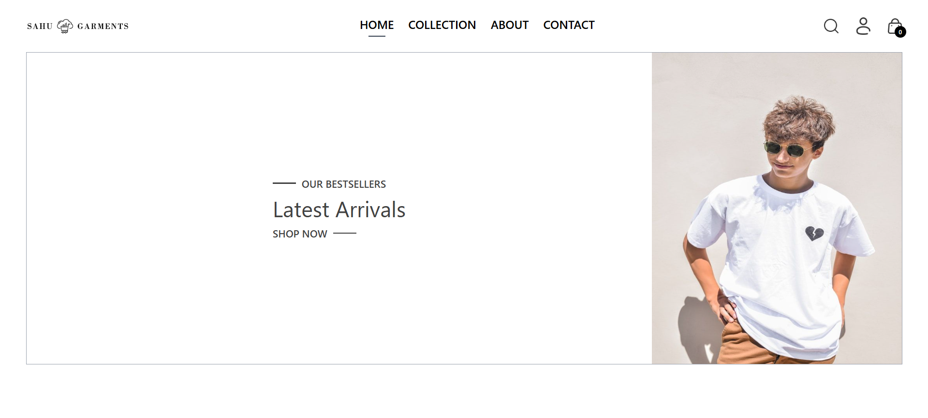

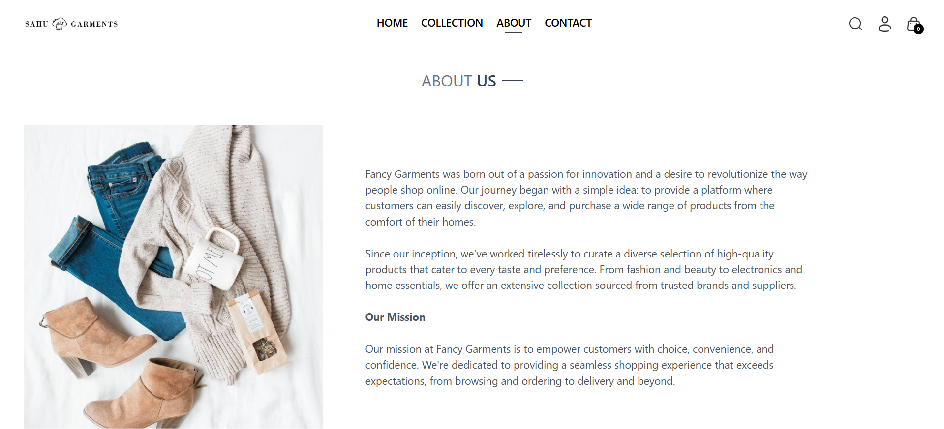

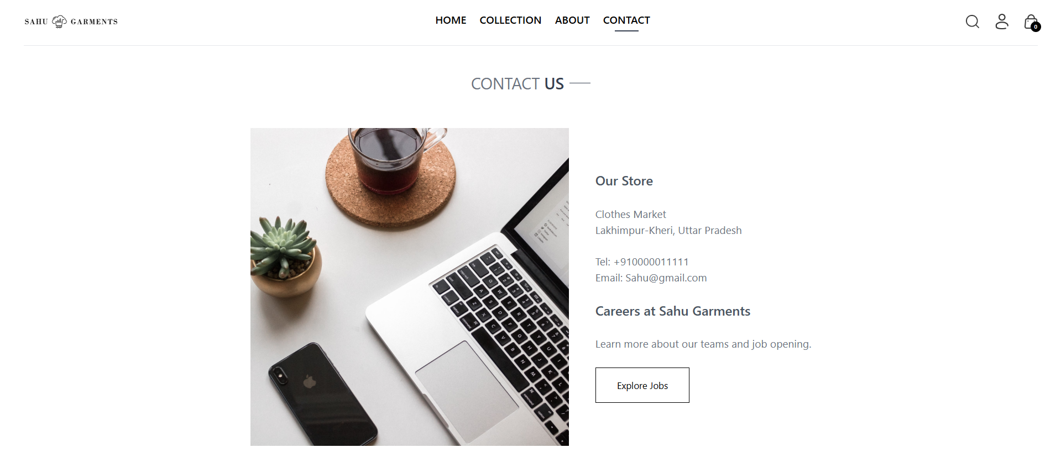

User Registration and Login: Shows user data moving from frontend to backend.
Product Search and Filter: Shows data flow from the database to the user interface.
Checkout Process: Flow from cart to payment gateway and order confirmation.

A. Appendices
Appendices may be used to provide additional (and hopefully helpful) information. If present, the SRS should explicitly state whether the information contained within an appendix is to be considered as a part of the SRS’s overall set of requirements.

Example Appendices could include (initial) conceptual documents for the software project, marketing materials, minutes of meetings with the customer(s), etc.

5. GITHUB LINK:-

https://github.com/anjeetpatel/SahuGarments

Deployed Link:-

https://sahugarments.netlify.app/

6. Client Approval Proof:-

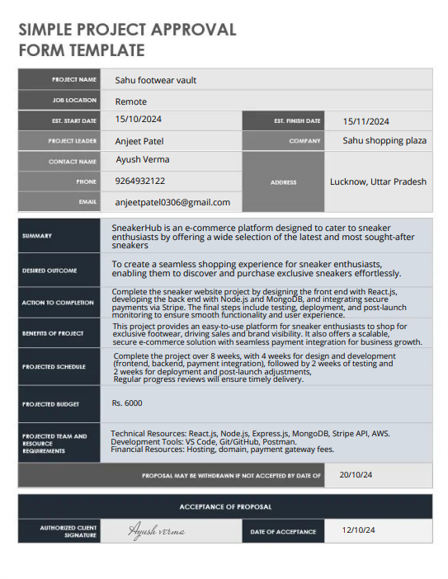

A.1 Appendix 1
Glossary of technical terms specific to the Sneaker Hub platform and e-commerce.

A.2 Appendix 2
Documentation of API integrations, including parameters, error handling, and response examples for payment and login services.

